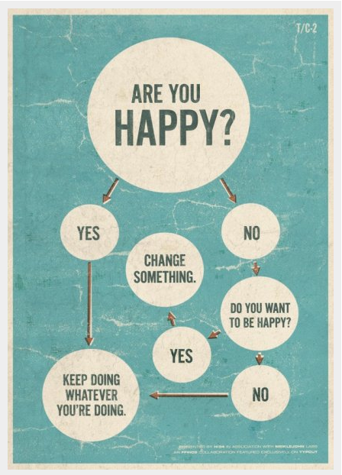
Research Infographic Project

Due Dates: Rough Draft 1: Thursday, 5/3 (end of hour)
Rough Draft 2: Tuesday, 5/8 (end of hour)
Final Draft: Wednesday, 5/9 (end of hour)

ALL DRAFTS OF THIS PROJECT WILL BE SUBMITTED TO OUR BLOG.

Goal:
The goal of this project is two-fold. The first is for you to learn how to thoughtfully and critically sift through information to find research that is reliable, useful and scholarly. Then the second goal is for you to use that research to support YOUR OWN conclusion and represent those conclusions in a creative and alternative manner.

Context:
You are wrapping up high school. You have learned a lot over four years, but hopefully you still have questions…you still wonder about things.

Prompt:

What do you want to know?
Come up with a question that you want to answer. This should be something that you want to know—not something you already know about. Research it. Dig into it. Now draw some conclusions—answer your own question. Be creative in how you present it.

Process Foci
Research | Here will we focus on the qualities of good researchers. Can you follow the 5 steps wisely and thoughtfully.
Representation and Citation of Evidence | Now that you have gathered a slew of information, how can you creatively communicate it to an audience? How, then, do you responsibly cite that information?
Organization | The focus here will be on grouping ideas logically and determining a flow for those ideas that makes sense, visually, on the page.
Skill Foci
Word Choice | Together we will be looking at choosing just the right word for what you are communicating. Because we are limited in our wording here, it will be important to say EXACTLY what we mean.
Design Theory | One element of this project that is not explored elsewhere, but probably should be, is design theory and considering how things look on page. We will aim to be thoughtful in proximity, contrast and repetition of elements on the page.

Participation Resources
A portion of your grade each quarter is a participation grade. This participation grade will be based largely on your use of the resources listed below. Our goal is to be motivated to become better writers—and sometimes that involves going above and beyond or helping each other out. Participating in both or either of these activities on a regular basis will meet the participation requirements for the class

Writing Lab This is a great resource with an online sign up (www.pedesigns.com/go/hswl)! Visit early and
visit often. These teachers know what they’re doing. Please make sure to fill out the conference prep sheet (on SP) and take it with you to your appointment. Turn these in as you have your appointments.

Website I have created a writing question discussion board on our website. If you have questions while
Discussion you’re working on your writing, post them here. I will check this and other students will check
Board this. Your participation in both asking and answering questions

Blog As you experienced with our diagnostic essay, peer feedback can be valuable. Peer revision, however,
Peer Reviews does not work well if ALL students do not participate. Please make sure you complete these assignments not just for your grade, but for your classmates’ benefit.

